# Durable Furnitures

Interlude Home

## Bella Chandelier

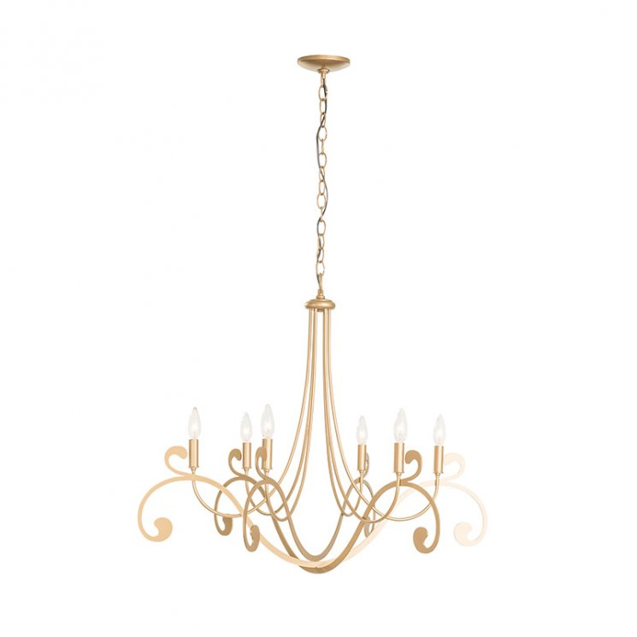

Like something out of a fairy tale book, the Bella Chandelier is sheer elegance in a stunning luminescent form. Handcrafted by Hubbardton Forge artisans, the Bella Chandelier is all graceful sweeping curves with six candelabra-style bulbs reaching upwards from its steelwork. The effect of the soft light glinting off of the expertly forged metal creates a dreamlike atmosphere to your surroundings. Escape into a world of sophisticated charm with a Bella Chandelier in your own home.